CHEMICAL ENGINEERING TRANSACTIONS  VOL. 96, 2022 | A publication of
The Italian Association
of Chemical Engineering
Online at www.cetjournal.it

Guest Editors: David Bogle, Flavio Manenti, Piero Salatino
Copyright © 2022, AIDIC Servizi S.r.l.
ISBN 978-88-95608-95-2; ISSN 2283-9216

Eco-design of Products as an Energy-Environmental Strategy for Agro-Industrial Development
Lourdes I. Meriño^{a,}*, Juan D. Sepúlveda^{b}
ªGrupo Bioprocesos, Universidad del Atlantico, Sede norte: Cra 30 # 8-49 Puerto- Atlántico- Colombia
^{b}Grupo 3I+D, Universidad del Atlantico, Sede norte: Cra 30 # 8-49 Puerto- Atlántico- Colombia
lourdesmerino@mail.uniatlantico.edu.co
Rural areas provide, in addition to food, raw materials to industry, and despite its importance, these areas and their processes are not independent of causing negative impacts on environment, so, as a development strategy for these territories, it is proposed the eco-design of high-value products, free of toxic compounds that help to reduce soil, air and water pollution and at the same time increase productivity and competitiveness. Due to the economic impact of cosmetic products and the need for energy to carry out agro-industrial processes, raw materials that can be used in these two sectors were selected; Then, an inventory of raw materials with high potential to produce cosmetic products and the availability of residual biomass with energetic characteristics was carried out. The selected species were corn, coconut, and wood such as eucalyptus. Gross Calorific Value of coconut residues is highest (10443 Btu/lb) compared with maize residues (8841 Btu/lb) and eucalyptus wood (8310 Btu/lb); residual moisture and volatile matter are higher for coconut waste, compare with maize waste and eucalyptus wood too. According with results, briquettes of agro-industrial wastes (coconut and maize) were made and evaluated in combustion, although they have values of calorific power lower than pure material, there is the advantage that they can be a better alternative to be used as solid fuel.
Briquettes with the best performance were coconut with a Gross calorific value of 9235 Btu / lb, although the percentage of ash was higher in the residues of ground corn (zea mays) (3.87% on dry basis). Eucalyptus oil and coconut oil were evaluated to prepare cosmetic products, highlighting solid shampoo as an innovative product. Results of this work allowed to establish the potential for the use of the agro-industrial waste studied in processes of energy use for combustion and the acceptability of the elaborated shampoo.

  - Introduction
In Colombia there is a growing trend towards the consumption of products that are natural and at the same time friendly to the environment, this has been reflected by the increase in green businesses generating development for the country, with 4,332 direct jobs and 81,127 million in sales (Minciencias, 2017). Simple and fast access to information has allowed the consumer to handle a large amount of information regarding the products used and the elements that compose it and encouraging the constant search for new information, having the ease of knowing those products that can generate well-being (Martí et al, 2006).
In Colombia, the development of high-quality cosmetics, produced based on natural ingredients, expands the generation of new economic opportunities, setting trends due to differentiating factors, such as quality, functionality, and the use of innovative ingredients characteristic of the great biodiversity. (Safe Colombia, 2015). Natural ingredients in the cosmetic sector have been highly appreciated by people, due to their low or null production of side effects and their wide functionality, such is the case of substances such as fats, waxes, juices, vegetable extracts, natural colorants and essential oils, the latter well known for their strong aromas, to which various properties have been attributed such as antifungal, insecticide, antibacterial, antioxidant, among others, which have allowed their implementation in different branches of the industry for the creation of products such as perfumes, soaps, hair products, bioinsecticides, among others (Mejía, 2018) (Bakkali, 2008).
The use of crop, forest and agro-industrial residues has been investigated in relation to the environmental impacts caused by not being treated properly, in this sense an alternative is to use them as solid fuel to replace wood and avoid burning forests (Morales, et al, 2022). The implementation of energy solutions that use agro-industrial or forest residues have been positive for the mitigation of impacts to the air, soil, and water (Martínez, et al, 2021). In this research, eco-friendly products were designed based on the functional properties of raw materials from the region; corn and coconut residues were used for energy supply, and coconut and eucalyptus oil were used for the cosmetic sector.
  - Methodology
This research was done at three steps: Raw material inventory, characterization and products development, figure 1 shows methodology.
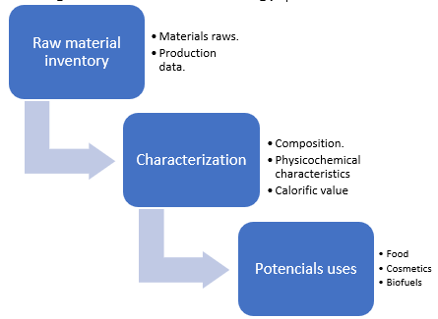
Figure 1: Methodology steps
Inventory data of raw materials was obtained from the official statistics of the information and communication network of the Colombian agricultural sector (Agronet, 2022), data on planted area, production and yields of crops found in the departments of the Colombian coast were analyzed. Next, the main crops were selected according to the economic and environmental impacts they have for the region. At an economic level, the analysis focused on the importance for the generation of economic capacities and at an environmental level, the impacts were analyzed due to the amount of waste generated and the use of this waste.
Then the physicochemical characteristics of the selected raw materials were determined, the composition, humidity, ash, and calorific value of the biomass generated in each crop and the properties to be used to elaborate functional products were analyzed. Table 1 shows the methods used for the characterization.
Table 1: Characterization method
Analysis | Technique
Residual Moisture, pct. wt. | [ASTM D-3173-17]
Volatile matter, pct. wt. | [ASTM D-3175-17]
Ash, pct. wt. | [ASTM D-3174-12]
Fixed carbon, pct. wt. | [by diff]
Gross calorific value, Btu/Lb | [ASTM D-5865-13]
Fat determination | [Soxhlet method]
Based on the characteristics and properties of the raw materials, the designs of the functional products were made in accordance with the methodology for solving environment problems and taking advantage of local capabilities, through which design thinking tools are used to arrive at a design that contributes to the solution of identified problems. The steps shown in figure 2 were followed to design main products and its impacts in solution problems. Inspiration stage included immersion in the community to understand its problems and capabilities; then, the ideation stage was participatory based on design for sustainability (Ozgen, 2022). Prototyping and minimum viable product was development on implementation stage and validated for community.
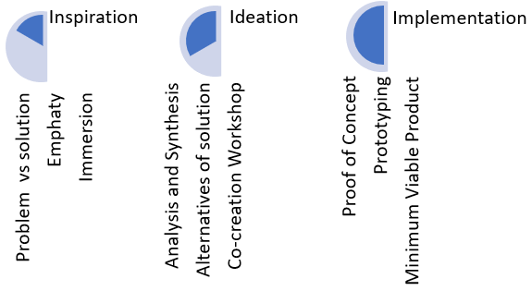
Figure 2: Design methodology.
  - Results
    - Raw materials Inventory
The north coast of Colombia has territories that base their economy on agricultural production, maritime activity, and the manufacturing industry, where the agro-industrial sector combines its efforts to produce products from raw materials in the region and that can be exported by the ports that are in the area. Agricultural activity is concentrated on products destined for the local fresh market or to produce food products, which is why recovery efforts are focused on taking full advantage of all raw materials, whether for food or non-food purposes. Figure 3 shows the main agricultural products of the region.
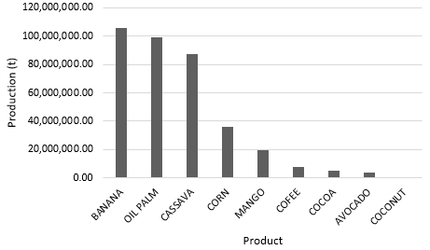
Figure 3: Main agricultural products of north coast of Colombia.
Production of oil palm is used as an alternative for energy purposes to produce biofuels (biodiesel) while the residues of banana, corn, cassava, coconut, and cocoa crops can be used for solid biofuels. In this regard, the use of solid fuels has been implemented as a strategy to reduce the felling of forests. In the last decade, research has been carried out on the use of forest residues, using them as fuel. Research has shown positive results since said waste turns out to be ecological, allowing renewable energy solutions to be provided through briquettes, both to the industrial sector and to the urban and rural population. Authors such as Sarmiento, who designed and prepared lignocellulosic fuel briquettes mixing and waste wood at Barranquilla – Atlántico (Sarmiento, 2018) and on the other side Wamukonya and Jenkins, determined the possibility of producing durable briquettes from sawdust and wheat straw as possible fuel for Kenyan households and small industries (Wamukonya, 1995).
Production of cocoa and coffee in the region has been strengthened in recent years, as shown in table 2, mainly for export, highlighting good agricultural practices and organic crops that meet strict international standards. Regarding the cosmetic sector, there is an increase in the consumption of personal care products with antioxidant properties such as those of cocoa, coffee, and essential oils. Hence the importance of eucalyptus crops in the region, 53 hectares in 2018, with a production of 371 tons.
Table 2: Production of cocoa and coffee
Year | Cocoa (area ha) | Coffee (area ha)
2020 | 530,572.00 | 3,834,936.00
2019 | 523,908.00 | 3,779,664.00
2018 | 362,404.00 | 3,413,206.72
Cosmetic sector in Colombia is a leader in the Andean region and is searching for strategies that allow its recognition in Latin America. Without a doubt, the efforts of this sector to prevail have been fruitful, because exports of cosmetic products for care personnel rose by 12.3% annually. According to the above, it was evidenced that hair products are the second most representative segment within cosmetic exports in Colombia (Safe, 2015). In this sense, the use of products from the region to strengthen the cosmetic sector has been one of the reasons for product research and development.

    - Characterization of raw materials
For the residual biomass of corn, it has a predominant composition of hemicellulose, holocellulose and lignin. In addition to being used as solid fuel, the residual biomass of corn combusted in oxidizing atmospheres produces a synthesis gas with a high calorific value (Fonseca, 2017). The residual biomass of the Coconut or Mesocarp, represents 35% of the fruit, it is composed of dry fibers (125 g approx.) and pith tissue powder (250 g approx.) which makes up approximately 375 g of dry mesocarp for each fruit. The mesocarp of coconut is composed mainly of lignin, cellulose, and hemicellulose, which give it a high-water retention and absorption capacity, which allows it to be used as solid fuel (Rincón, 2016). Table 3 shows the main properties that stand out in the region's raw materials.
Table 2: Properties of corn waste and coconut waste
Analysis | Corn waste | Coconut waste
Residual Moisture, pct. wt. | 4.62 | 8.83
Volatile matter, pct. wt. | 83.78 | 92.16
Ash, pct. wt. | 3.87 | 0.49
Fixed carbon, pct. wt. | 0.10 | 0.03
Gross calorific value, Btu/Lb | 8,841 | 10,443
Residual Moisture, pct. wt. | 4.62 | 8.83
Additionally, due to its properties, coconut oil has been used to combat multiple conditions due to its analgesic, antibacterial, antidiarrheal, hypoglycemic activity according to phytochemical studies, this fruit contains phenols, tannins, leukoanthocyanidins, flavonoids, triterpenes, steroids, and alkaloids (Lima, 2015), this allows it to be considered as a raw material or additive in cosmetic preparations. Similarly, Eucalyptus (Eucalyptus globulus L.) has various uses such as: firewood, wood for commercial and family use, extraction of essential oil. The main components of the essential oil are: 1,8- cineol, α-pinene and L- pinocarveol (Boukhatem, 2014).
    - Products designed
Based on the properties of the raw materials, prototype designs were made following the design thinking methodology, the products that met the energy and environmental criteria with the maximum use of waste were the briquettes made with corn and coconut waste, in figure 3 the briquettes obtained are shown, which were tested in basic food cooking processes.
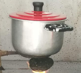
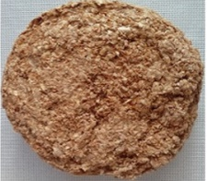
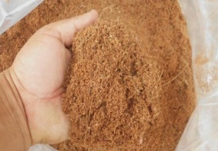

Figure 4: Briquettes made with corn and coconut waste
Cosmetic product evaluated with the best potential to enter the market was the solid shampoo that uses coconut, avocado, and eucalyptus essential oils in its formulation. The use of Eucalyptus globulus L oil was based on studies carried out by Luís et al., in 2015, who determined the properties of E. globulus oil as antioxidants and antibiotics against bacteria such as A. baumannii (Duarte, 2015). Regarding coconut oil, researchers E. E. Bassey et al., conducted a study on the antimicrobial and antifungal susceptibility pattern of coconut oil extract in selected bacteria and fungi, where the phytochemical content of coconut oil, which contains compounds such as alkaloids, glycosides and terpenoids, was evaluated. which were attributed multiple health benefits and antimicrobial properties when observing the average inhibition of the zones, obtaining an average inhibition of 14.55 mm (32%) for Staphylococcus aureus, Streptococcus pneumonia 12.1 mm (27% ), Escherichia coli 10.95 (24%) and Pseudomonas aeroginosa in a smaller proportion with 7.7 mm (17%), in turn, the results obtained with fungi were 18.55 mm (55%) for Candida albicans and 15.1 mm (45%) for Aspergillus fumigatus (Meneses, 2015).

    - Characteristics of solid shampoo
Product designed is a solid shampoo in the shape of a truncated cone, colour greyish green, weighing 65 gr and volume of 23 cm³, whose shape and measurements are shown in Figure 5.
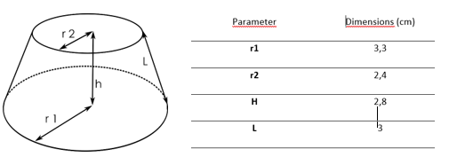
Figure 5: Shape and measurements of solid shampoo
According to the results of the acceptability of the solid shampoo, the strategies proposed in the figure 6 are available.
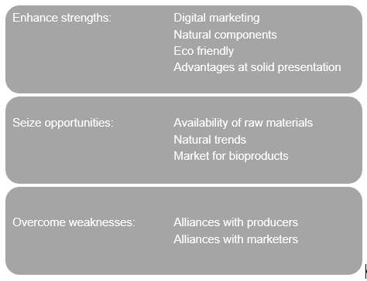
Figure 6: Strategies to increase acceptability.

  - Conclusions
These sustainability strategies allow the designed products to represent an economic benefit for the producers, strengthening the productivity of the region with the comprehensive use of raw materials and the reduction of environmental impacts. Two economically and environmentally important sectors were identified: energy and cosmetics. To take advantage of the energetic properties of residual biomass, briquettes were designed and for the cosmetic sector, solid shampoo was a viable alternative.
Acknowledgments
Universidad del Atlántico, Vicerrectoría de Investigación, extensión y proyección social.
References
Agronet, Red de información y comunicación del sector agropecuario colombiano, Available in: [https://www.agronet.gov.co/estadistica/Paginas/home.aspx?cod=1.
Bakkali F., S. Averbeck, D. Averbeck, y M. Idaomar, “Biological effects of essential oils – A review,” Food Chem. Toxicol., vol. 46, no. 2, pp. 446–475, 2008.
Boukhatem M. N., M. A. Ferhat, A. Kameli, F. Saidi, K. Walid, y S. B. Mohamed, “Quality Assessment of the Essential Oil from Eucalyptus globulus Labill of Blida (Algeria) Origin”, Int. Lett. Chem. Phys. Astron., vol. 36, pp. 303–315, 2014.
Duarte, J Â., Luís, A.. Gominho, F. Domingues, y A. P. Duarte, “Chemical composition, antioxidant, antibacterial and anti-quorum sensing activities of Eucalyptus globulus and Eucalyptus radiata essential oils”, Ind. Crops Prod., vol. 79, pp. 274–282, 2015.
Fonseca S., Rodríguez H., Camacho G., 2017, “caracterización de residuos de maíz del municipio de Ventaquemada Colombia” Universidad Libre de Colombia, Departamento de Ingeniería Mecánica. Bogotá – Colombia.
Gamarra Ramos L. A., 2010, «Fabricación y evaluación de eficiencia y emisiones de briquetas a base de residuos agrícolas como alternativa energética al uso de leña,» Zamorano, Honduras.
Lima E. B. C., “Cocos nucifera (L.) (Arecaceae): A phytochemical and pharmacological review.”, Brazilian J. Med. Biol. Res. = Rev. Bras. Pesqui. medicas e Biol., vol. 48, no. 11, pp. 953–64, 2015.
Martí F. Pablo, E. Mañas Alcón, y J. R. Cuadrado Roura, “El impacto de las TIC en las formas de consumo familiar", F. Pablo Martí, E. Mañas Alcón, y J. R. Cuadrado Roura, España, 2006
Martinez A, Meriño L., Albis A., Ortega J., 2021, Comparative study of the reaction kinetics of three residual biomasses, BioResources 16 (20, 2891 - 2905).
Mejía Zapata C., “Estudio sobre bioeconomía”, Medellín, 2018.
Meneses A. K. López, M. Plascensia Jatomea, J. Lizardi Mendoza, E. C. Rosas Burgos, y E. Al, “Antifungal and antimycotoxigenic activity of essential oils from Eucalyptus globulus, Thymus capitatus and Schinus molle”, Food Sci. Technol., vol. 35, no. 4, pp. 664–671, 2015.
Minciencias. Los negocios verdes impulsan el desarrollo de Colombia. 25-Oct-2017. [En linea]. [Accedido: 13-Sep-2020]. Disponible en: https://minciencias.gov.co/sala_de_prensa/los-negocios-verdes-impulsan-el-desarrollo-Colombia.
Morales D., Lizarzaburu D., Castaneda-Olivera C.A., Benites Alfaro E., 2022, Solid Biofuel Spheres for the Use of Residual Biomass from Polylepis (quenual) in Rural Areas, Chemical Engineering Transactions, 92, 157-162.
Ozgen S., 2022, Particulate Matter Emission Reduction from Pellet Boilers: Status, Potentiality and Challenges, Chemical Engineering Transactions, 92, 457-462.
Rincón Reyna J.F. Rincón P., 2016, “caracterización fisicoquimica y funcional de la fibra de mesocarpio de coco (Cocos nucifera L.)” Escuela Nacional de Ciencias Biológicas, Instituto Politécnico Nacional. Departamento de Ingeniería Bioquímica, Universidad Politécnica de Pachuca.
Safe, "Análisis de competitividad del sector cosméticos e ingredientes naturales", Safe, Bogotá, 2015.
Safe, “Dinámica comercial y económica del sector cosméticos e ingredientes naturales en Colombia”, Safe, Colombia, 2015.
Sarmiento S., Bermudez J., Meriño L., 2018. Evaluación del uso de biomasa residual maderable como combustible, basada en las características fisicoquímicas de tres recursos forestales de la región caribe colombiana, Trabajo de grado, Ingeniería Agroindustrial, Universidad del Atlántico, Colombia.
Wamukony L. B. Jenkins, 1995, “Durability and relaxation of sawdust and wheat-straw briquettes as possible fuels for Kenya” Biomas and Bioenergy.

